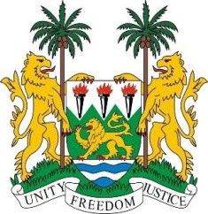
SIERRA LEONE

20th Session of the UPR

STATEMENT BY AMBASSADOR STEVENS

27 October 2014

Mr President,

Sierra Leone welcomes the high-level delegation of El Salvador and thank them for the presentation of their very comprehensive report, which was prepared as a result of an inclusive process. My delegation believes it reflects the government’s commitment to the promotion and protection in a broad and collaborative manner.

My delegation commends El Salvador for the recent 2014 ratification of the ICCPR- OP2, with a view to eliminating the death penalty. Sierra Leone would also like to commend El Salvador for meeting its reporting requirements to the Treaty Bodies.

Although poverty remains a challenge for the achievement of social inclusion and equality, El Salvador has shown its commitment to better improving the lives of its people - and in particular women - by establishing and reinforcing policies through national legislation with a view to promoting equality, eliminating violence against women, and reducing maternal mortality. El Salvador has also made noticeable progress in the recognition of indigenous peoples and in providing reparation for victims of the worst forms of human rights violations.

While my delegation notes with interest the efforts undertaken to promote the rights of the child, we believe El Salvador should put into action further measures and programmes which limit the worst forms of child labour and reduce the incidence of children joining street gangs.

Finally, Sierra Leone would like to make the following recommendations:
- El Salvador should ratify the optional protocol of the CEDAW, which was signed in 2001.
- Further promote education for children, especially in the rural areas and at secondary level.
- Promote the adoption of new national migration legislation.
- Enforce existing legislation on women’s, children’s and adolescents’ rights

My delegation would like to conclude by wishing El Salvador every success in the completion of this review process.

Thank you, Mr President.

